


LOCAL ROADS CONNECTIVITY PROJECT
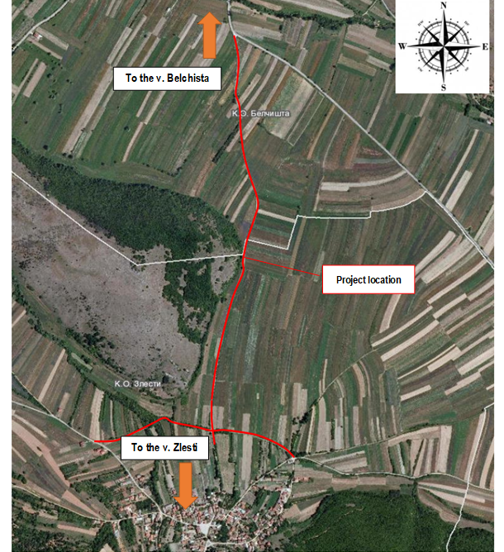
September 2020
2020
ENVIRONMENTAL AND SOCIAL MANAGEMENT PLAN (ESMP)
Upgrading of local road from village Zlesti to village Belchista (section 1 and 2), Municipality of Debrca

Prepared by:
Slavjanka Pejchinovska-Andonova, MSc, Environmental Engineer
Environmental and Social (E&S) Specialist
TABLE OF CONTENTS
1. INTRODUCTION 1
2. PROJECT DESCRIPTION 2
2.1 Baseline condition of Municipality of Debrca 2
2.1.1 Demography 2
2.1.2 Climate features 3
2.1.3 Seismology 4
2.1.4 Water 4
2.1.5 Air quality 5
2.1.6 Waste 5
2.1.7 Geology and soil 5
2.1.8 Flora and fauna 5
2.1.9 Noise 7
2.1.10 Cultural heritage 7
2.2 Project location 7
2.3 Project Activities 9
2.4 Sensitive receptors 9
3. POTENTIAL ENVIRONMENTAL IMPACT AND RISK AND IMPACT AND RISK ASSESSMENT 10
Implementation of ESMP 12
Grievance mechanism 13
Public disclosure and citizen engagement 15
Public consultation 15
4. ENVIRONMENTAL AND SOCIAL MITIGATION PLAN 17
5. ENVIRONMENTAL AND SOCIAL MONITORING PLAN 20
6. ANNEX 25

FIGURES
Figure 1 Location of the project area in relation with the Municipality of Debrca 2
Figure 2 Map with potential natural hazards (erosion, floods, landslides and earthquakes) in RNM 4
Figure 3 Some fauna representatives related to the project site in Municipality of Debrca 6
Figure 4 Landscape of Belchishko swamp 6
Figure 5 Location of the upgrading local road in the Municipality of Debrca 7
Figure 6 Current situation of the project area in Municipality of Debrca 9
Figure 7 Location of IPA “Ilinska Mountain” related to project location 25
Figure 8 Location of IВA “Lake Ohrid” related to project location 25
Figure 9 Location of Emerald site “Belchisko swamp” related to project location 25
Figure 10 Location of the project location related to MAK-NEN network (bio corridor for brown bear) 25
Figure 11 Graphic figures of the layout of relevant local road 26

TABLES
Table 1 Planned project activities in Municipality of Debrca 9
Table 2 Potential impacts and risks 10
Table 3: Estimated values of demolition waste generated during sub-project activities 11
Table 4 COVID-19 considerations in construction/civil works projects recommended by WB 28

ANNEXES
Annex 1 Maps of sensitive areas in the wider and close surrounding of the project site in Municipality of Debrca 25
Annex 2 Layouts of the local road in Municipality of Debrca 26
Annex 3 COVID-19 considerations in construction/civil works projects 27
Annex 4 Form for submitting comments 33
Annex 5 Grievance Form for whole project implementation period 34

ABBREVIATIONS
EIA | Environmental Impact Assessment
EHS | Environment, health and safety
ESMF | Environmental and Social Management Framework
ESMP | Environmental and Social Management Plan
ES | Environmental and social
ESS | Environmental and social standards
IPA | Important Plant Area
LRCP | Local Road Connectivity Project
MOSHA | Macedonian Occupational Safety and Health Association
MoEPP | Ministry of Environment and Physical Planning
MSC | Macro seismic
MoTC | Ministry of Transport and Communications
OH&S; OHS | Occupational Health and Safety
PE | Public Enterprise
PIU | Project Implementation Unit
PPE | Personal protection equipment
RM | Republic of Macedonia
RNM | Republic of North Macedonia
WHO | World Health Organization

INTRODUCTION
The current condition of the local road network (as part of the transport sector in RNM) is characterized with poor condition, unsatisfactory level of financing of road maintenance on national level and as well as weakness of international investment in distribution sector and transport sector. Responsible for the poor condition of the local roads is the fact that the financial capacity of the Local Self Government is different from region to region within the country. Many of the local roads that are in bad condition leave people with no access to hospitals, schools and markets so this issue brings social problems as well.
With a 70 million Euro investment secured by the World Bank, in order to support the municipalities in RNM, the Ministry of transport and communications (MoTC) will implement the Local Roads Connectivity Project (LRCP) regarding mostly rehabilitation of existing local road infrastructure (urban / rural streets, regional and local roads), reconstruction, rehabilitation, upgrading, pedestrian paths, street lighting, water drainage and capacity building of municipal staff.
According to the national environmental requirements (Law on Environment and secondary legislation), for these type of projects it is necessary to submit a Notification Letter for intention to start the project to the Ministry of Environment and Physical Planning (MoEPP) which initiates the environmental impact assessment procedure and based on the issued Opinion, to prepare the EIA Report. If the issued Opinion of the MoEPP is positive and EIA Report has to be prepared, the Municipality of Debrca shall prepare an EIA Report
The EIA Report will be prepared in accordance with Article 24 of the Law on Environment (Official Gazette of the Republic of Macedonia No 53/05, 81/05, 24/07, 159/08, 83/09, 48/10, 124/10, 51/11, 123/12, 93/13, 187/13, 42/14, 44/15, 129/15, 192/15, 39/16 and 99/18) and the Rulebook on the form and contents of the EIA Report in accordance with the types of activities for which the report is being prepared, as well as in accordance with the entities performing the activity and the scope of activities being performed by the legal and natural entities, the procedure for their approval, as well as the method for keeping of the register of approved reports (Official Gazette of the Republic of Macedonia No 44/13, 111/14).
EIA Report was prepared for this project, in November 2016, by the company “Proekt Biro” from Ohrid because according to the national legislation activities that includes upgrading and rehabilitation of roads belongs in the chapter X – Infrastructure projects, item 1 Upgrading of local roads, defined in the secondary legislation. For the EIA Report Mayor of Municipality of Debrca on 15.03.2017 issued а Decision for approval number 09-159/3.
The Municipality send a copy of the EIA Report together with the Decision to the MoTC with other technical documents for approval.
In September/October 2019, in order to address Project’s potential environmental and social concerns in accordance with the requirements of the World Bank Environmental and Environmental and Social Framework (ESF), Environmental and Social Management Framework (ESMF) was prepared for the whole LRCP project. The ESMF is used as a basis for the creation of site specific Environmental and Social Management Plans (ESMP) and ESMP Checklists which will address in detail environmental and social aspects of sub-projects identified in the course of project preparation and implementation.
The aim of the relevant project is to improve the road infrastructure in Municipality of Debrca trough upgrading the local road from the village Zlesti to the village Belchishta, which is consist of two sections: Section 1 (with length of 720 m) and Section 2, (with length of 1,401 m). The total length of the road is 2,121 m. According the Main design for the project, the main activities will include: removal of low steamed vegetation (bushes), earthworks (excavations), excavation and installation of pipe culverts, setting a buffer layer and asphalting), etc.
Currently, the route is asphalted with an average width of 3.0 m, but due to the long life and its poor maintenance, in some places there have been holes and subsidence. The upper side of the road is destroyed. Completely upgrading process of the local road is planned to be finished within 30 days.
The purpose and need for the upgrading of this local road is reflected in improving the situation with the local road network in the Municipality of Debrca. It will facilitate the access to the surrounding agricultural fields. At the same time, the local road will facilitate access to the v. Belchishta, as well as the management of the surrounding forests, extinguishing forest fires, etc.
Taking into account the nature of project activities, technical specifications, size of the road, location of upgrading activities the nature, size, location, as well as the specifics of the potential environmental impacts during the upgrading of local road from village Zlesti to village Belchista, the Project Upgrading of the local road in Municipality of Debrca, was classified as project with substantial risks, which requires the preparation of Environmental and Social Management Plan (ESMP) in accordance with the WB environmental and social standards.

PROJECT DESCRIPTION

Baseline condition of Municipality of Debrca
The Municipality of Debrca geographically belongs to the Ohrid-Prespa Basin and is located in the southwestern part of the Republic of Macedonia. The highest point of the municipality is at 2,242 m a.s.l., and the lowest is at 697 m above sea level. It covers an area of ​​424 km², with a total of 30 settlements. The seat of the municipality is in village Belchishta.
The municipality borders with Municipality of Kichevo to the northeast, Municipality of Demir Hisar to the east, Municipality of Ohrid to the south, and Municipality of Struga to the west. In Figure 1 location of the project site regard the location of the Municipality of Debrca is presented.
Municipality of Debrca
Figure 1 Location of the project area in relation with the Municipality of Debrca

Demography
The latest census data in the RNM was the 2002 census. According to the 2002 census data, this municipality has 5,507 inhabitants, with population density of 12.95 people/km². Ethnic groups in the municipality include Macedonians with total 5,324 citizens (96.7%); Albanians with total 153 citizens (2.8%); and others with total 30 citizens (0.5%). Municipality of Debrca is characterized by an unfavorable demographic structure, with greater representation of mature and elderly population. In v. Zlesti lives 294 inhabitants and the v. Belchishta lives about 484 inhabitants. According to the gender aspect, within Municipality of Debrca, 2,544 are men and 2,522 are women. At 10 years of age and over, the literacy of the population in the municipality is following: 4671 are literate and 395 are illiterate. From total 5,507 inhabitants, the educational attainment (at 15 years of age and over) is following: without education are 391; incomplete primary education are 1068; primary school are 1743; secondary school are 1378; high school are 95; faculty are 70, master is 1; and still in the process of primary education are 3.

Climate features
The climatic characteristics of the Municipality of Debrca depend on the morphological characteristics of this area. The air temperature is quite uneven and is accompanied by pronounced temperature oscillations. Depending on the geographical location and proximity to the Adriatic Sea, the climate should be Mediterranean. However, due to the enclosure of the terrain with high mountains that prevent Mediterranean influence and altitude, the climate is modified Mediterranean, with significant features of temperate continental. The region of the municipality is characterized by moderately warm summer temperature, with an average of maximum up to 34 degrees, as well as moderately cold winter temperatures, with absolutely minimum temperature up to minus 17 degrees. There are on average about 75 summer days in the region, ie days that have a maximum daily temperature above 25 degrees. The average annual rainfall is between 700 and 820 mm/m². The rainiest month is November. In previous years, the snow reached a height of over 50 cm, but in recent years the snow cover has decreased significantly and for a long time remains only on the mountain tops. Early autumn and late spring frosts are common, as well as morning spring fogs, followed by the appearance of frost, which adversely affect crops. Summer is sometimes characterized by the appearance of prolonged dry periods. In previous years, the snow reached a height of over 50 cm, but in recent years the snow cover has decreased significantly and for a long time remains only on the mountain tops. Early autumn and late spring frosts are common, as well as morning spring fogs, followed by the appearance of frost, which adversely affect crops. Summer is sometimes characterized by the appearance of prolonged dry periods. In previous years, the snow reached a height of over 50 cm, but in recent years the snow cover has decreased significantly and for a long time remains only on the mountain tops. Early autumn and late spring frosts are common, as well as morning spring fogs, followed by the appearance of frost, which adversely affect crops.
The most common winds in the municipality blow from north to south, along the valley of the river Sateska, which in winter bring cold and snow, and in summer coolness. In spring and autumn, the south is more noticeable. Here we can list the local winds that blow from Golak, Mazatar, Ilinska planina, Karaorman and Slavej, which are of insignificant speed and bring coolness and rain in summer. The average wind speed is relatively low at 3.4 m/s.
Floods and landslides
Municipality of Debrca is part of Southwest Planning region. Southwest Planning region have two areas with risk of erosion and floods: Debar area and Ohrid-Struga area. The project location belongs within the Ohrid-Struga area. Lake Ohrid has a very torrential character. A special problem is the river Sateska. She has the largest sediment transfer (112.907 m³/year). In addition to mechanical pollution with sediment, river Sateska also causes chemical pollution. Other torrential rivers in the Lake Ohrid watershed are the Koselska River, Skrabatska, Vapilska, Sirulska and Letnicka River. The majority of the watershed (42%) is under low erosion processes. The most severe forms of erosion account for only 6% of the watershed, but they are huge sources of sediment. In Figure 2 is presented location of the project area regards the risk of flooding, landslides and erosion in RNM.
(source: http://www.southwestregion.mk/media/24018/giz_jugozapadenregion_razvojnaprograma_vnatresni_makedonski_posledna.pdf).
Source: http://app.gov.mk/wp-content/uploads/2015/04/%D0%9030104-PP-na-RM-2002-2020.pdf
Figure 2 Map with potential natural hazards (erosion, floods, landslides and earthquakes) in RNM
According to Figure 2, the project location in Municipality of Debrca is characterized with high risk of floods and low risk of landslides.

Seismology
According to the analysis of the seismic activity of the Municipality of Debrca, earthquakes with maximum intensities not exceeding 7 degrees MCS (Mercalli scale) have been registered. Earthquakes with an intensity of 8 degrees on the Mercalli scale are assumed to be possible, which is why it is recommended to provide adequate seismic protection when planning construction activities.

Water
Territory of the Municipality of Debrca is characterized by a large number of water reservoirs, rivers and springs. Certainly, the largest is the Sateska River, which covers 39.36% of the total surface of the Lake Ohrid watershed. The catchment area of ​​the Sateska River covers 420 km² and there are the following water resources: Vrbjanska River, Slivovska River, Godivska River, Mramorechka River, Brezanska River, Ilinska River, Srpnica, Zletoska River, Botunska River and Trebeni. Torrential rivers in the municipality are Crna and Slatinska.
An important water resource for the municipality is Slatina Lake. Slatina Lake is an artificial reservoir, built in 1963. It is supplied with water from the Mramorechka River and has a total volume of 1,400,000 m³ and a dam height of 15.5 m. The waters of this lake are used for irrigation of the agricultural areas in Slatina, Izdeglav and Ozdolen field, with a total of 420 ha, but also for sport fishing and tourism. The water quality in the lake is at the highest level because there is no organic or inorganic pollution. From the other accumulations, the accumulation of the dam Pesochani should be mentioned, on which the hydro power plant “Pesochani” was built, as well as the natural accumulation near the village Trebenishta.
A very interesting hydrographic object on the territory of the municipality is the swamp between the villages Belchishta and Novo Selo, known as Belchishko swamp or "Sini Viroj", which is a relic of the former Desaret Lake, with which Debrca was flooded in the Pliocent. With the withdrawal of the Desaret Lake, along the Sateska River, numerous endemic species of flora and fauna remained to continue to exist in the waters of the "Blue Viroj" swamp. Belchishko swamp is the largest preserved water habitat in N. Macedonia, with an area of ​​about 0.5 km². The swamp area is used by the surrounding inhabitants for grazing and watering cattle, mowing, fishing, hunting and recreation (picnic spot).

Air quality
The monitoring of the ambient air quality in the Republic of North Macedonia, is performed by the Ministry of Environment and Physical Planning, which manages the State automatic air quality system composed of 17 measuring stations of which 5 are located in Skopje. The closest measuring station to the project location is the one in City of Kichevo, located northeast from the project location in Municipality of Debrca at about 25.3 km. In this air quality measuring station, monitoring is performed of the following parametars: sulphur dioxide, nitrogen dioxide, carbon monoxide, ozone and suspended particles with size of 10 micrometers (PM₁₀).
At the Kichevo monitoring station, the number of exceeded of threshold limit values in 2019, are the following parameters: PM₁₀ was for 77 days; NO₂ concentrations were 7 exceedances of threshold limit values; SO₂, O₃ and CO concentrations have not exceeded the threshold values.

Waste
For collection and transportation of the inert and communal waste is responsible PCE “Debrca”. There are 2 landfills of temporary character within the municipality:
- One for v. Belchishta, Leshani, Velmej and Zlesti which covers an area of ​​1,800 m²; and
- One landfill for the v. Meseishta, Orovnik, Treven, Volino which covers an area of ​​1,600 m².
No infrastructures for water and electricity are present at these landfills. There is no treatment of the disposed waste.
There are seven dumps / illegal landfills in the municipality (covering an area of ​​2,100 m²), where the waste is inadequate disposed: near v. Godivje, v. Selo, v Ozdoleni, v. Orovnik, v. Mesheishta, v. Volino, v. Trebenishta and v. Gorenci. No studies have been conducted on the impact of these illegal landfills on groundwater and soil, but they degrade space.
Because there is no appropriate alternative landfill for waste disposal from project activities, the generated inert waste and communal waste streams should be disposed at first temporary landfill for v. Belchishta and Zlesti.

Geology and soil
The geological structure of the municipality consists mostly of alluvial formations, pluvial sediments, spread in the plain part. Alluvial deposits in terms of engineering-geological characteristics are mostly labile terrains with low values ​​of physical-mechanical properties.

Flora and fauna
The project site is a rural area and is zone of agricultural activities. The surroundings include agricultural-natural habitats and a landscape with steppe elements. The route of the road, in terms of biology, has been strongly changed by past and present agricultural activities. The natural vegetation (in south part of the project site) belongs to following biomes: southern European, (mostly represents by deciduous forests) and sub-Mediterranean, (mainly represents by deciduous forests and shrubs). Characteristic plant communities for these biomes are: ass. Quercetum frainetto-cerris, as well as elements of ass. Querco-Carpinetum orientalis. Typical species of vertebrates in the area of ​​the route are:
- Amphibians and reptiles: Hermann's tortoise (Testudo hermanni), Balkan green lizard (Lacerta trilineata), common ryegrass (Ablepharus kitaibelii), Greek frog (Rana graeca), yellow snake (Dolichophis caspius), mountain snake (Coronella austriaca), horned viper (Vipera ammodytes), etc.
- Birds: the most numerous are representatives of barn swallow (Hirundo rustica), hawk mouse (Buteo buteo), large colorful woodpecker (Dendrocopos major), dove (Streptopelia decaocto), chicken hawk (Accipiter gentilis), etc.
- Mammals: brown bear (Ursus arctos), wolf (Canis lupus), fox (Vulpes vulpes), wild boar (Sus scrofa), roe deer (Capreolus capreolus), forest dormouse (Dryomys nitedula), European badger (Meles meles), yellow-necked mouse (Apodemis flavicolis), wild rabbit (Lepus europaeus), etc.

Hermann's tortoise (Testudo hermanni) chicken hawk (Accipiter gentilis) brown bear (Ursus arctos)
Figure 3 Some fauna representatives related to the project site in Municipality of Debrca
Biological and landscape diversity within the project area, includes certain characteristic and rare species of flora and fauna, as well as endangered species according to international and national strategic documents in the field of nature protection. Of particular importance is the presence of the brown bear (Ursus arctos) - an endangered and strictly forbidden species for hunting. The wider area around the route has been identified as a bio corridor through which large beasts migrate. The corridor connects Stogovo / Karaorman on west, with Ilinska / Plakenska / Bigla Mountain to the east.
A very interesting habitat and ecosystem on the territory of the municipality is the swamp between the villages Belchishta and Novo Selo, known as Belchishko swamp or "Sini Viroj", which is a relic of the former Desaret Lake, with which Debrca was flooded in the Pliocent. With the withdrawal of the Desaret Lake, along the Sateska River, numerous endemic species of flora and fauna remained to continue to exist in the waters of the "Blue Viroj" swamp. Belchishko Blato is the largest preserved water habitat in Macedonia, with an area of ​​about 0.5 km². The swamp area is used by the surrounding inhabitants for grazing and watering cattle, mowing, fishing, hunting and recreation (picnic spot). Botanically, this area is rich in floristic biodiversity. Especially interesting and important are some old oak forests and black alder forests. Quercus pedunculiflora is a very rare oak species in N. Macedonia. Rare insects (dragonflies, butterflies), reptiles and amphibians are also found. The main threats to this area are mostly activities related to illegal logging, illegal opening of fishponds along the river Crna and others. There are also some quarries in this area that are located near the site proposed for protection. The landscape of the Belchishko swamp is given in Figure 4.
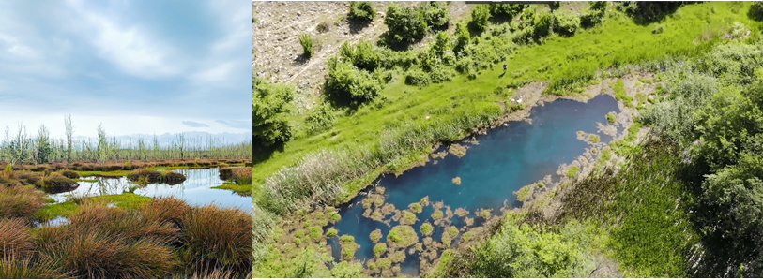
Source: http://www.belciskoblato.mk/gallery.html
Figure 4 Landscape of Belchishko swamp
The Belchishko swamp is part of the national Emerald network and future NATURA 2000 area. This swamp is located about 1.2 km northwest from the project area.

Noise
The environmental noise is monitored only in the bigger cities in the RNM. In the Municipality of Debrca there is no monitoring station, and thus the noise pollution is not monitored. There are no recorded complaints about increased level of noise at the project site.

Cultural heritage
From the cultural and historical heritage of the Мunicipality of Debrca, there are churches and monasteries of which the most characteristic are: the Monastery of “St. John” in the village Slatino dates from the 1st century BC, as well as the churches St. “Peter and Paul”, the church of St. “Nicholas”, etc.

Project location
The project area, where the project activities for upgrading of local road will be performed, is located in the southwest part of RNM, more precisely in the central part of the Municipality of Debrca. In Figure 5 the location of the project area near v. Belchista and v. Zlesti is presented.
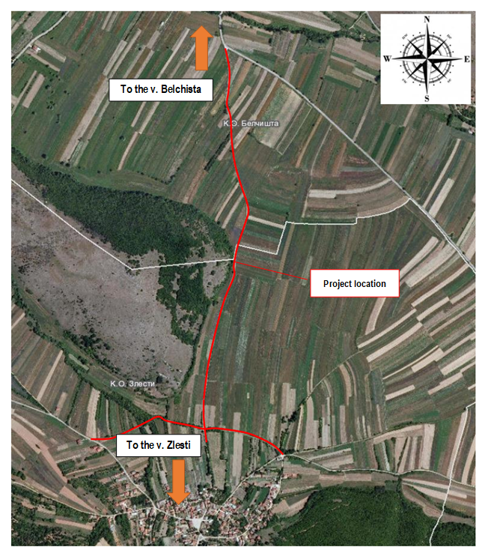
Figure 5 Location of the upgrading local road in the Municipality of Debrca
Near the project site (about 500 m northwest from the project site) Important Plant Area (IPA) “Ilinska Mountain” is located. In the wider surrounding of the project location in Municipality of Debrca is located Important Bird Area (IВA) “Ohrid lake” (about 16.8 km southwest from the project site). A maps with the listed sensitive areas regards project location, is presented in Annex 1.
The local road alignment consists of two sections. Section 1, which is 720 m long and runs along the north side of the village Zlesti. This section of the station km 0 + 300 intersects with section 2 which extends from the village Zlesti to the village Belchista and is 1401m long. The terrain crossing the route of section 1 is equidistant with a height difference of 1.0 m. The terrain passing through Section 2 can also be characterized as a plain with a height difference of 10 m.
The route of the first section starts at the northeast part of the village Zlesti from the junction that leads to the village Leshani, with an elevation level of 781.97 m a.s.l and moves relatively straight along the outskirts of the village of Zlesti and joins the local road leading to the v. Botun at an elevation of 782.86 m asl. The route of the second section starts at junction 0 + 300 km with the first section with elevation level of 782.79 m a.s.l and hence continues relatively straight with a longitudinal inclination towards the village Belchishta. Section 1 ends at km 1 + 401 with the formation of a junction with the road v. Belchista – v. Lesani at an elevation of 772.81 m a.s.l.
The current condition of Section 1, which is 720 m long, is such that the pavement structure is not asphalted, it is ground with irregular horizontal and vertical elements of the alignment. This section is expected to remove the 10.0 cm underground layer, compact the substrate and apply a buffer layer of separated crushed stone to the projected floors of not less than 20.0 cm in thickness. Above the buffer layer is laid an asphalt layer of BNAS 16 with a thickness of 7.0 cm and a width of 3.0 m. The soft shoulders of this section are also made of 0.5m wide buffer material. The existing condition of Section 2, which is 1,401 m long, is such that it is paved with asphalt which due to the long life of exploitation and maintenance is completely degraded. This section envisages that the existing asphalt layer will remain and a buffer layer over it will be laid over the projected elevations not less than 20.0 cm thick. This will raise the level of the carriageway above the terrain and allow normal drainage of the carriageway construction.
The PIU (represents from the MoTC and responsible staff from Municipality of Debrca) conducted a site visit on the project location, in order to determine the current condition of the relevant road. The following situation of the project location was noted:
- The width of the road is 3 m;
- The terrain on the sections of the local road section from the v. Zlesti to the v. Belchista can be treated as a flat terrain;
- The terrain on which the alignments extend is composed of earth materials of category III, IV;
- From the hydrological point of view it can be estimated that there are no shallow ground waters or permanently wet places on the routes;
- On the both sides of the route of the road, agricultural fields are located.
The current conditions of the local road in Municipality of Debrca, can be seen through site visit photos of the both sections, given in Figure 6.
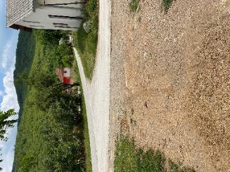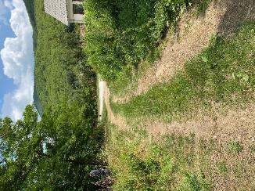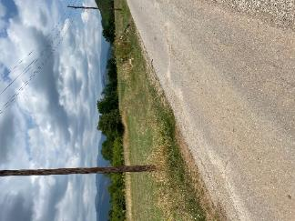
a) Section 1

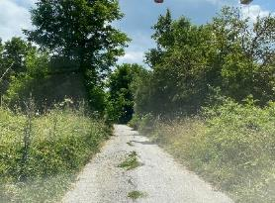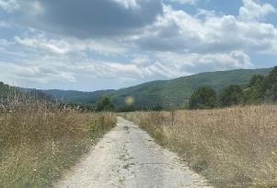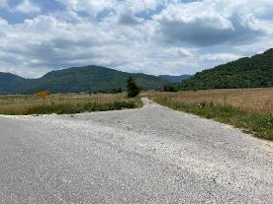
b) Section 2
Figure 6 Current situation of the project area in Municipality of Debrca
According the Main design for the project, the main activities will include: removal of low steamed vegetation (bushes), earthworks (excavations), excavation and installation of pipe culverts, setting a buffer layer and asphalting), etc.

Project Activities
The planned project activities will be performed in three phases: preparatory activities (marking out and clearing up of the road that will be upgraded), upgrading of the road (installation of crushed stone material, putting asphalt layer, etc.), and operational phase (activities related to regular and preventive maintenance of relevant road). The layout of the planned upgrading is shown in Annex 2. The total length of the new road will be 2,121 m. The main project activities are presented in Table 1.
Table 1 Planned project activities in Municipality of Debrca
Project location | Project phases | Project Activities
Upgrading of local road from village Zlesti to village Belchista (section 1 and 2) | Preparatory activities | - Removal/ clearance of vegetation;  - Marking and securing the route at the project location.
 | Upgrading phase | - Excavation of humus and soil;  - Procurement, transportation and installation of concrete pipe culverts;  - Procurement, transportation and installation of crushed stone material;  - Application of asphalt layer with a thickness of 7.0 cm on crushed stone material and compaction of the layer;  - Construction of road shoulders (machine excavation of soil and installation separated crushed stone with a thickness of 15 cm and a width of 0.5 cm;
 | Operational phase | - Clean up the upgrading site;  - Maintenance in the winter period.

Sensitive receptors
Sensitive receptors that will be affected during the preparation activities and upgrading phase, are: workers (who will be engaged during the upgrading phase) and local population (who will gravitate along the local road, especially farmers/owners of the agricultural fields). Also, as sensitive objects that need to be taken into consideration during the implementation of the project activities, are the agricultural fields. This conclusion is referring in aspect of increased level of noise, air emissions and easy access to the agricultural fields.

POTENTIAL ENVIRONMENTAL IMPACT AND RISK AND IMPACT AND RISK ASSESSMENT
The project activities will be implemented in three phases: preparatory activities, upgrading of the local road, and operational phase.
Land acquisition is not envisaged for the relevant project, because the property of the land where the local road is located is state owned. For the needs of the Contractor for temporary placement of machinery and equipment at a location in the immediate vicinity to the project that is privately owned (if there is a need), it is necessary to sign a Contract with the owner of the parcel for temporary land usage during project implementation period. The Contract will define terms and obligations for land usage or other premises (ex. garage, storage area, etc.) in line with the Project RPF Furthermore, all compensation will be paid before the respective land is accessed.
The potential impact and risks are shown in Table 2.
Table 2 Potential impacts and risks
Preparatory phase | Upgrading phase | Operational phase
- Clearing and marking out the route of the road; | - Procurement and transportation of upgrading materials;  - Excavation of soil;  - Installation of crushed stone material;  - Paving of the local road; | - Clean up the upgraded site;  - Transportation of the generated waste to the landfill,
Possible impacts
- OHS risks  - Safety risk for local population | - OHS risks  - Community safety risks,  - Air quality,  - Noise,  - Waste generation  - Water pollution | - Waste generation,  - Noise  - Air emissions
Aspect: OHS and Community Safety
As a result of implementation of the project activities in the rural area of Municipality of Debrca, the main adverse environmental impact can be seen trough: 1) increased level of noise (produced from the usage of construction machinery); 2) possible air emissions; 3) improper waste management; 4) possible water pollution; 5) incompliance with OHS requirements; and 6) possible risk on local population. Main obligatory activities prior the start of sub-project activities that should be conduct from the Contractor are: preparation and implementation of OHS Plan including Labor management procedures (in order to prevent injuries of workers on project location), preparation and implementation of Traffic management plan with time schedule of project activities and directions for re-routing the traffic flow (in order to provide proper transportation of goods and people within project site, with directions for re-routing the traffic) and also preparation and implementation of Community Safety Plan (with proper preventive measures which should be part of the project design documentation). In order to provide maximum safety for local population during project activities, the Contractor should marked, fenced and placed alert signalization along the route of the local road (prohibition for entrance of unemployed on upgrading site). The Grievance mechanism and forms for complaints by the surrounding population should be on their disposal during the upgrading activities. The forms should be posted in the municipality office, local community office, contractor’s office and construction site. The preparation and releasing of Information note/Press from the municipal staff should be performed also before the start of the sub-project activities with detailed information about the type of upgrading activities and their duration (announced via municipality web page (https://debrca.gov.mk/) and municipality board. Workers should wear PPE. They also must be informed on Grievance Redress Mechanism, as well as the right to organize in workers organization, by their employer the Contractor/Sub-contractor. The grievance forms could be post in the mobile containers for the workers. All engaged workers must have regulated full employment status during their assignation on this project, and all their health and pension insurance must be covered in full for the engaged period by their employer.
Considering the current situation with COVID-19 in the country, in addition to the measures for safety and protection at work, the OH&S plan also should include measures for prevention of COVID -19. Detailed description of the measures and recommendations from the World Bank/WHO and MOSHA are presented in Annex 3. The CОVID-19 prevention measures contains recommendations from the World Bank / WHO, as well as recommendations from the Macedonian Occupational Safety and Health Association in the form of a Guide that the Contractor of the construction works needs to implement. The Contractor is required to follow/update and implement the measures that are currently in force and adopted by the Government as binding at national level. Official site for information related to COVID 19 on national level is https://koronavirus.gov.mk/.
Aspect: Air quality
During the upgrading phase of the local road in Municipality of Debrca, the possible air emissions that may occur are from operation of the mechanical machinery and equipment (dust and gas emissions). In operational phase of the local road, air emissions will be generated from mobile sources of pollution – vehicles. To prevent and avoid adverse environmental impacts the Contractor should imply mitigation measures given in the Mitigation Plan (table below).
Aspect: Level of Noise
The operation of heavy machinery will also generate increased level of noise and vibration during the road upgrading. Taking into consideration the noise sensitivity of the project location and national legislation for noise protection (Official Gazette of RM No.79/07, 124/10, 47/11, 163/13 and 146/15) the project for upgrading of local road belongs in area with IV degree of noise protection because of the presence of agricultural fields along the route of the local road (the maximum limit values should not exceed 60 dB(A) for night and 70 dB(A) for evening and day).
Aspect: Waste management
The proper waste management of the different waste streams that will be generated on the upgraded site of the local road in Municipality of Debrca (such as soil, communal waste) should be implemented such as: appropriate selection, transportation and final disposal (according to national legislation Law on Waste and List of Waste codes – Official Gazette of RM No. 100/05). Waste Management Plan should be prepared and implemented by the Contractor in order to prevent possible waste disposal near/in the river Treska. As part of this plan, the options for reuse/recycling of the generated waste streams should be included. The responsible legal entity for transportation and final waste disposal in Municipality of Debrca is PCE “Debrca” (the final waste disposal will be performed at the one of the temporary landfills in Municipality of Debrca, relevant for v. Belchishta and Zlesti). The estimated values of generated waste streams (according to the Main Project) are presented in Table 3.
Table 3: Estimated values of demolition waste generated during sub-project activities

Type of waste | Name of the project location
Type of waste | Upgrading of local road from village Zlesti to village Belchista (section 1) | Upgrading of local road from village Zlesti to village Belchista (section 2)
Excavation of soil (in m³)  List of waste, code: 17 05 04 | 77.7 | 204.71
Removal of vegetation (in m²)  List of waste, code: 17 02 01 | 2,204.36 | 4,203.66
Removal of humus layer (in m³)  List of waste, code: 17 05 06 | 450.5 | /
Removal of concrete elements (no. of pieces)  List of waste, code: 17 01 01 | 4 | /
Demolition waste (in m³)  List of waste, code: 17 09 04 | 116 | 316.68
Aspect: Water pollution
In the wider surrounding of the project location (about 3 km west from the project site), passes Sateska River (belong to Lake Ohrid watershed) and as water recipient is classified in II class (low level of pollution-mezotrophic status, high level of autopurification which can be used for fish growing, bathing, water sports and recreation). In order to prevent possible water pollution the Contractor should respect and imply requirements given in national legislation for water sector. In order to maintain good ecological status of river Treska, the Contractor should forbid temporary or final waste disposal near /in river band of this water recipient (e.g disposal of soil, leakages of motor oils and lubricants, etc.). Belchishko swamp is located in the wider surrounding of the project site (about 1.2 km northwest from the project area). This water body is characterized with high sensitivity regarding the water quality. No wastewater emissions are expected to generate during the upgrading road phase, that could affect this natural monument.
Aspect: Biodiversity
During upgrading phase, the removing of the surrounding vegetation and excavations along the route of the road, can cause animal disturbance and permanent or temporary loss of part of the habitats of some animals. As the vegetation along the route is mostly composed of grass habitats and shrubs, its removal will adversely affect reptiles, some species of birds and mammals. Given that this is a relatively small area, and similar habitats are significantly present in the surrounding areas and in general in Municipality of Debrca, this impact can be taken as negligible.
Upgrading of the local road will not cause fragmentation of habitats because the entire route has already been constructed and used, and the animals have adapted to the current situation. The most important is the fact that the frequency of vehicles is extremely low and increases only for the season of agricultural activities (a part of route), weekends and religious holidays. Fragmentation of aquatic habitats is also not envisaged. During the operational phase, animal mortality (amphibians, reptiles and mammals) is also possible. It can be estimated that the overall impact will be small taking into consideration the low vehicle speed (limited to 30 km/h) and low traffic frequency.
Monitoring of the implementation of the proposed environmental measures should be performed by the Supervisor but also by the municipality staff (Communal Inspector, Environmental Inspector, Project Manager) who will visit the project locations more frequently and together with the Supervisor will monitor if the proposed measured have been applied.
The proposed preventive and mitigation measures are presented in the Mitigation and Monitoring Plan tables.

Implementation of ESMP
This ESMP should be a part of the Contract that the PIU will sign with the Contractor for implementation of the project activities. The Contractor is obligated to perform all proposed preventive or mitigation environmental and social measures in this plan and to keep the evidence of any documents related to applying these measures (e.g., letter asking the municipality for disposal of inert waste, records on OHS training performed for all workers before start of activities, all developed EHS plans, etc.). The OHS training should be organized by the Contractor for all workers prior start the project activities and prior any specific tasks with high health risks. The training should be delivered by the authorized OHS company and everyday OHS risks should be assessed by the Contractor’s OHS responsible person working on the location on daily basis. Evidence for all trainings delivered should be kept.
Measures prescribed in the EIA Report together with the measures within the ESMP will be a mandatory requirements for the Contractor during the implementation of the construction activities.
The Supervising Engineer needs to monitor the implementation of proposed measures by the Contractor and Contractor’s subcontractors with visual checking, reviewing the records of evidence that the measures have been applied and ask the Contractor to apply the measures as soon as possible. The non-compliances should be recorded and the Report on any non-compliances should be reported to the municipality (Project Manager) immediately, and the Project Manager will report it to the PIU. The Environmental/Social Specialist engaged by the PIU will report the non-compliance and accidents/ emergencies cases to the Bank, immediately upon occurrence. Each non-compliance should be closed with appropriate measure/s and the evidence should be kept. The regular monthly report should contain all environmental and social issues raised during that period and the evidence on solutions should be provided as well. PIU will have main responsibilities regarding the Project implementation, project coordination, monitoring activities and reporting.
The Environmental/Social Specialist engaged by the PIU will be responsible for ensuring proper environmental management of all Project activities, conduct environmental supervision by carrying out document reviews, site visits and interviews with Contractor, Supervising Engineer and municipality staff. She/he will supervise Contractors’ compliance with ESMP and visit the project location at least once a month and the Monitoring Report reflecting main issues and arrangements and timing for their solution will be prepared and submitted to the PIU. The semi-annual Project Report should contain a chapter with Environmental/Social risks/impacts of the project and the status of implementation the ESMP proposed measures.
The municipality has a main role for daily monitoring of project activities engaging the Supervising Engineer and coordinating all activities on location nominating the responsible person – Project Manager.
The PIU need to organize regular meetings with the Project Manager, Contractor, representatives from MoTC, responsible person from the Municipality of Debrca and the ES specialist on a monthly basis or during any site visit.
Good communication between all involved stakeholders (Contractor, Supervisor, municipal staff, Environmental Inspector, Communal Inspector, PIU from MoTC and other relevant persons from Municipality of Debrca) is very important for providing continuous performance of the project activities and successful completion of overall project. The PIU from MoTC and project manager from the Municipality of Debrca will facilitate good communication and coordination of the project activities on spot.

Grievance mechanism
PIU within the MoTC has introduce a Grievance Mechanism to ensure that it is responsive to any concerns and complaints particularly from affected stakeholders and communities.
For the purposes of receiving comments from the stakeholders (local citizens and workers onsite) PIU establish Mechanism procedure including the Grievance Form for the construction phase of the project (Annex 5) that will be available in electronic form on the MoTC web site (http://www.mtc.gov.mk/), Municipality web site (https://debrca.gov.mk/) and the Contractors web site.
Grievance Form for the construction phase of the project is prepared for the local population (if an incident or damage to private property occurs) and for the workers (grievance for lack of protective equipment, increased working hours, no period for rest, etc.) who will be involved in the construction activities.
Before starting with construction activities Contractor should inform the workers about the Grievance Form and the opportunity to express their compliances regarding the operation on the construction site. Local population will be introduced with this possibility by the Information posted on the Informative board within the Local Community, Municipal web site, and via local radio or local TV station.
The PIU will ensure that the GRM is responsive to any concerns and complaints particularly from affected stakeholders and vulnerable groups.
Following steps are to be taken to ensure full GRM functioning:
Step 1: Recording received grievance in the GRM registry;
Step 2: Providing the person who filed the grievance with an acknowledgment of receipt within 5 days of receipt;
Step 3: Investigating the grievance;
Step 4: Resolution of Grievance within 15 days of grievance receipt;
Step 5: Follow up.
In cases when the grievance/complaint is indefinite or not clear enough, the PIU will assist and provide advice in formulating/redrafting the submission, in order for the grievance/complaint to become clear, for purposes of an informed decision by the PIU, in the best interests of persons affected by the Project.
If the PIU is not able to address the issues raised by immediate corrective action, a long-term corrective action will be identified. The complainant will be informed about the proposed corrective action and follow-up of corrective action within 25 calendar days upon the acknowledgement of grievance. In situation when the PIU is not able to address the particular issue verified through the grievance mechanism or if action is not required, it will provide a detailed explanation/ justification on why the issue was not addressed. The response will also contain an explanation on how the person/ organization that raised the complaint can proceed with the grievance in case the outcome is not satisfactory. At all times, complainants may seek other legal remedies in accordance with the legal framework of Republic of North Macedonia, including formal judicial appeal.
Grievances can be filled verbally, by phone, in writing (by post or e-mail) or by filling in a grievance form (Annex 5). The grievance form will be made available on the implementing agencies website together with clear information on how feedback, questions, comments, concerns and grievances can be submitted by any stakeholder and information concerning the PIU’s managing of the GRM both in terms of process and deadlines. Furthermore, the website will include the possibility to submit grievances electronically.
In order to capture and track grievances received under the project, a dedicated GRM register is planned. Specifically nominated members of staff will record grievance information in the grievance registry. This will include:
- Number of Grievance;
- Date of receipt;
- Stakeholder name, sex, age and contact details;
- Date of acknowledgement;
- Description of grievance;
- Description of action taken;
- Date of grievance resolution;
The PIU will share the Grievance Registry with the WB on a monthly basis.

Public disclosure and citizen engagement
The Municipality of Debrca submits a draft version of this ESMP to review and approval of the PIU Environmental and Social Experts, who then (when confident that the document meets WB quality and content requirements) submits the draft document for the review and clearance by the World Bank. After the clearance is obtained, the document has to be publicly disclosed.
The Draft ESMP will be available for the public on web site of the Municipality of Debrca (https://debrca.gov.mk/) and the web site of the MoTC PIU (http://www.mtc.gov.mk/) accompanied by a Form for submitting comments (Annex 4). The social Media channels of the Municipality of Debrca that will be used for the purpose of raising awareness about the Project implementation and identified E&S risks, impacts and mitigation measures are the facebook page (https://www.facebook.com/) and the twitter page (https://twitter.com).
During the 14 days after the disclosure of the prepared ESMP document, the Municipality of Debrca will conduct video public consultation in order to inform the public on the proposed sub-project activities, anticipated impacts and the ways of their mitigation.
Public announcement will be developed with brief description about the purpose of the project, project activities and duration of the activities, environmental and social impacts, proposed measures, availability of the ESMP together with the Form for submitting comments on the MoTC web site and Municipality web site, Informative board within the Local Community. Announcement will also contain information about the possibility for citizens to raise opinion/ suggestion/comments on the prepared ESMP by filling the Form for comments and submission to the responsible person from MoTC Mrs. Irena Paunovikj (e-mail: irena.paunovikj.piu@mtc.gov.mk) . Form for submitting can be filled with a full identity or anonymously, and the comment or suggestion should be fully described in order to take it into account in the final version of ESMP. Information about the date and time for conducting the and the video public consultation, way how the stakeholder can take part on the video public consultation will also be a part of the announcement.
Public announcement will be published on the local radio or TV station and on the Informative board within the Local Community.

Public consultation
Considering the current situation with COVID 19 and the inability for organizing an ordinary public hearing event in the premises of the Municipality where the project will be implemented, the video public consultation will be organized, The MoTC PIU in cooperation with the municipality will define the date for the video public consultation (by using Vebex operational tool).
Municipality will need to inform all relevant stakeholders on its territory about the timing of the video public consultation (and to ask them for their e-mail address if they like to join the event), so that all from their homes/offices can follow the event and be active participants. If the stakeholders do not have the technical capabilities, the municipality will ensure an appropriate solution in order to be able to follow the event. The mailing list for participants will be prepared taking into account all relevant stakeholders and Invitation will be sent to those with brief explanation for the:
- Purpose of the video public consultation;
- Way how they can be registered and connect;
- Exact time and date for the event;
- Availability of the ESMP and
- Possibility for submitting comments on the prepared ESMP by filling in the Form for submitting comments and suggestions on the ESMP to the responsible person from PIU.
During the video consultation event after the presentation of the main project activities and main findings from the ESMP, present public (stakeholders) can raise their comments/questions/suggestions about the whole project and any concern that they think that it is important.
After maintaining the video public consultation and the 14-day period for submitting comments, the final version of the ESMP will be prepared and will include the public consultation report (including announcement of the event (media or personal) detailed description of the event, list of participants, minutes of meeting, the expressed comments) and the appropriate corrections in the document according to the received comments and remarks.
Final version of the ESMP will be available on the MoTC web site and Municipality web site for the whole period of the sub project implementation.
Contact person for project awareness and public consultation from MoTC:
Mrs. Irena Paunovikj, Responsible for public relations for the project,
e-mail: irena.paunovikj.piu@mtc.gov.mk

Contact person for project awareness and public consultation from Municipality of Debrca:
Mr. Ljupco Baleski, Associate - communal affairs and local roads from Municipality of Debrca,
e-mail: ljupco.baleski@gmail.com
mob.tel: 076/315-416

ENVIRONMENTAL AND SOCIAL MITIGATION PLAN
Potential impact | Impact scale | Proposed mitigation measures | Responsibility
Project activities: Preparation activities before upgrading the local road in Municipality of Debrca: Marking out the route, putting security signs, etc.
Aspect: OHS and Community Safety  Possible adverse social and health impacts to the population, drivers and workers due to:  - Lack of ensured safety measures at the start of upgrading works;  - Injury passing near by the upgrading site;  - Not compliance with strict OHS standards and work procedure;  - Inappropriate public access within the local road from village Zlesti to village Belchista (section 1 and 2) | Local/ within the local road from village Zlesti to village Belchista (section 1 and 2)  Short term during the upgrading period  Significance - major | - Preparation, approval and implementation of OHS Plan prior start of activities;  - Preparation, approval and implementation of Community Safety Plan including Labor management procedures prior start of activities;  - Preparation, approval and implementation of Waste Management Plan (with reuse/recycling activities included) prior start up activities;  - Preparation, approval and implementation of Traffic management Plan during project activities (in correlation with municipality staff, prior start with the upgrading activities);  - Provision of the information via municipal web site (https://debrca.gov.mk/) local community, and municipality board about the type and duration of upgrading activities;  - The Contractor is required to submit a preliminary TMP, which will be part of the ESMP. Before the start of the project activities, the updated TMP with Community Safety Plan will be submitted to ESS. It will be presented to the workers on regular basis. TMP will specifically deal with safety of the pupils and local population using the road (walking / driving);  - Application of good upgrading practice for marking out the project site including:  - Ensure the appropriate marking out the project site, section by section along the local road;  - Placement of alert signs especially for limitation of speed driving near the road under upgrading;  - Placement of warning tapes;  - Installation of Notice board with general information about the project, Contractor and Supervisor at project location;  - Forbidden of entrance of unemployed persons within the warning tapes;  - Community and Worker’s OH&S measures should be applied (first aid, protective clothes for the workers, appropriate machines and tools);  - During the project activities, the Contractor should provide easy access of the local population to their agricultural fields, along the route of the local road;  - The road should be kept clean;  - The mobile toilet should be placed on the project site;  - Machines should be handled only by experienced and trained personnel, thus reducing the risk of accidents;  - Trying to avoid compliance, if any appeared recording grievances and promptly response and overcome the problem;  - Constant presence of firefighting devices should be ensured in case of fire or other damage;  - All workers must be familiar with the fire hazards and fire protection measures and must be trained to handle fire extinguishers, hydrants and other devices used for extinguishing fires;  - Larger quantities of flammable liquids should not be kept on the site along the road under upgrading.  - All engaged workers on this project must have regulated employment status by Contractor/sub-contractor and must receive full health and pension insurance, all in compliance with local labor related legislation and ILO standards. | - Contractor –Bidder  - Supervisor  - Municipality staff (Communal Inspector and Environmental Inspector)
Project activities: Upgrading of the local road in Municipality of Debrca
Aspect: Air quality  Possible emissions by transportation vehicles and impact on air quality along the relevant road in Municipality of Debrca, due to:  - Gases emissions of dust-suspended particulates  - Traffic congestion will be caused as well causing changes in existing traffic circulation | Local/ within the local road in Municipality of Debrca (in length of 2,121 m)  Short term/ major | - Upgrading road, transportation routes and materials handling sites should be water-sprayed on dry and windy days;  - Upgrading materials should be stored in appropriate places covered to minimize dust;  - Vehicle loads likely to emit dust need to be covered;  - Usage of protective masks for the workers if the dust appears;  - Restriction of the vehicle speed within the upgrading location;  - Perform regular maintenance of the vehicles and upgrading machinery in order to reduce the leakages of motor oils, emissions and dispersion of pollution;  - Burning of debris from ground clearance not permitted. | - Contractor –Bidder  - Supervisor
Aspect: Level of Noise  Possible noise disturbance as a result of outdoor equipment usage and transportation vehicles driving around the site | Local/along the project location in Municipality of Debrca  Short term /medium | - The project location belongs to area with IV degree of noise protection because of the presence of the agricultural fields along the route of the local road (the maximum limit values should not exceed 60 dB(A) for night and 70 dB(A) for evening and day).  - The upgrading work should be not permitted during the nights; the operations on site shall be restricted to the hours 7.00 -19.00.  - The control of noise level should be performed before the start up with the working activities and during work peaks; | - Contractor –Bidder  - Supervisor
Aspect: Water pollution  Possible impact on water courses – Sateska River and Belchisko swamp | Local/near relevant water bodies in Municipality of Debrca  Short term/ major | - Minimize storage or disposal of substances harmful to water – Sateska River and Belchisko swamp;  - In order to maintain good ecological status of the relevant water bodies, the Contractor should forbid temporary or final waste disposal near the relevant water bodies (e.g disposal of soil, asphalt, leakages of motor oils and lubricants, etc.)  - The road should be kept clean and tidy to prevent the build-up of oil and dirt that may be washed into a water course or drain during heavy rainfall. | - Contractor –Bidder  - Supervisor
Aspect: Waste management  Possible adverse environmental impact and health effects could occur as a result of generation of the different waste streams  The inappropriate waste management and not in time collection and transportation of waste streams | Local/ within the project location in Municipality of Debrca  Short term/ major | - Identification of different waste types at the upgrading site (soil, humus, bottles, food, etc.);  - Classification of waste according the national List of Waste (Official Gazette no.100/05);  - The main waste would be classified under the Waste Chapter 17 “Construction and demolition wastes (including excavated soil from contaminated sites)” with the waste code, 17 09 04 – Mixed waste from construction site;  - Small amount of solid municipal waste could be found (food, beverages), as well as packaging waste (paper, bottles, glass, etc.). Proper containers/waste bins should be provide at the project site during the upgrading activities;  - Collection and transportation of the inert and communal waste should be performed by PCE “Debrca” from Debrca (the final waste disposal will be performed at the one of the temporary landfills in Municipality of Debrca, relevant for v. Belchishta and Zlesti). The options for reuse/recycling of the generated waste streams should be taking into consideration;  - The recycle and re-use of some waste materials is obligatory (not to dispose them as a waste )  - Possible hazardous waste (motor oils, vehicle fuels) should be collected separately and authorized collector and transporter should be sub-contracted to transport and finally dispose the hazardous waste;  - The materials should be covered during the transportation to avoid waste dispersion;  - Burning of waste in the site or around is prohibited. | - Contractor –Bidder  - Supervisor  - Municipality staff (Communal Inspector)  - Mayor of the Municipality of Debrca;  - PCE “Debrca” from Debrca;
Aspect: Biodiversity  Possible adverse impact: habitat fragmentation, noise disturbance and possible animal mortality | Local/ short term/ with minor significance along the project site in Municipality of Debrca (especially near the IPA “Ilinska Mountain” and Emerald site “Belchisko swamp” | - Taking into consideration the frequency of vehicles and the small width of road (3.0 m), there is no need to build crossings for wild animals (overpasses or ecoducts);  - On areas that will not be directly affected by  construction work, the existing vegetation (autochthone trees and shurbs) will be kept and maintain, as well as habitats of reptiles, bird nests and shelters for small mammals. So, minimized the size of work the area as much as possible;  - The necessary removal of vegetation will be  performed outside the bird nesting season (September – February);  - Disturbance of the fauna by the workers is prohibited (generating increased noise from the construction machinery, collecting eggs from the nests of the fauna, etc.);  - The vehicles that are excessively noisy shall not be operated until corrective measures have been taken;  - Temporary or final disposal of hazardous waste (motor oils, vehicle fuels, lubricants) should be forbidden near the existing vegetation and near the Belchishko swamp; | - Contractor –Bidder  - Supervisor  - Municipality staff (Environmental Inspector)
Project activities: Operational phase of the local road in Municipality of Debrca
No adverse impact are expected in the operational phase of the project. Regular maintenance of the local road in the Municipality of Debrca, should be carried out (e.g. removal of snow in winter period, regular repair of the road surface, etc.). The vehicles that will gravitate in this project phase of the local road, should limited their speed according to the road conditions.

ENVIRONMENTAL AND SOCIAL MONITORING PLAN
What  parameter to be monitored? | Where  is the parameter to be monitored? | How  is the parameter monitored? |  | When  is the parameter monitored (frequency of measurement)? | Why  is the parameter monitored? | Cost |  | Responsibility
 |  |  |  |  |  | Upgrading | Operations | Upgrading the local road in Municipality of Debrca | Operation of the local road in Municipality of Debrca
Project activities: Preparation activities before upgrading the local road in Municipality of Debrca: Marking out the route, putting security signs, etc.
Application of PPE and protection measures for workers in order to minimize possible injuries at construction site | At the project site from village Zlesti to village Belchista (section 1 and 2) | Visual checks |  | During the clean-up activities  At the beginning of each working day during the sub-project activities | To prevent health and safety risks – mechanical injuries  To be in compliance with national communal health regulation and OH&S standards | Included in the project budget |  | Contractor/sub-contractors - Bidder  Supervisor  Communal Inspector at the Municipality of Debrca
Prepared all required documents related to OH&S, Community safety and Traffic Management | Within the project location |  | Review of the prepared documentation (OHS Plan  Community safety Plan  Traffic Management Plan (TMP) | During the clean-up activities  At the beginning of each working day during the sub-project activities | To prevent health and safety risks – mechanical injuries  To be in compliance with national communal health regulation and OH&S standards | Included in the project budget |  | Contractor - Bidder  Supervisor  Communal Inspector at the Municipality of Debrca
Training of workers and informing the local population about the project activities | At the project site in Municipality of Debrca |  | OHS training  By OHS authorized company engaged by the Contractor  Provision of the information via TV, radio and municipality web site (https://debrca.gov.mk/) about the project activities | Before the start up of the project activities | To prevent health and safety risks – mechanical injuries of the worker and local population  To be in compliance with national communal health regulation and OH&S standards | Included in the project budget |  | Contractor - Bidder  Supervisor  Communal Inspector at the Municipality of Debrca
Project stage: Upgrading the local road in Municipality of Debrca
Existence of applicable Traffic Management Plan for the project and Notices for the availability of the plan and information on traffic regulation set on municipality web site (https://debrca.gov.mk/) about the project activities | Within the project location | Visual monitoring |  | During the working day | To ensure the coordinated traffic flow through the project location and easy access of local population to their agricultural fields along the local road from village Zlesti to village Belchista (section 1 and 2) | Included in the project budget |  | Contractor - Bidder  Supervisor  Communal Inspector at the Municipality of Debrca
Use of PPE by the workers | At upgrading site | Visual monitoring |  | During the works | To ensure workers safety on site | Included in the project budget |  | Municipality of Debrca, Labor inspection
Forbidden disposal of the waste streams (solid and liquid) near Sateska River and Belchisko swamp, in order to prevent possible water pollution | Near Sateska River and Belchisko swamp, in Municipality of Debrca | Visual check if the waste is disposed near relevant water bodies |  | During the project activities (once per week) | To ensure good status of water quality of Sateska River and Belchisko swamp | Included in the project budget |  | Contractor - Bidder  Supervisor
Primary selection of the generated different waste streams at the project location | On the upgrading site near v. Zlesti and v. Belchista | Review the documentation |  | At the beginning of work with new material/s | In order to ensure separation of hazardous from the non-hazardous waste as well as inert from biodegradable waste | Included in the project budget |  | Contractor – Bidder  Supervisor
Collection and transportation of hazardous waste (if any occurs) | On safety temporary storage | Review the transportation list and conditions at the storage facility |  | Before the transportation of the hazardous waste (if there is any) | To improve the waste management practice on municipality and national level/ Not to dispose the hazardous waste on the waste disposal spots | Included in the project budget |  | Authorized Contractor for collection and transportation of hazardous waste (if any occurs)
Collection transportation and final disposal of the solid waste | At the upgrading site and near relevant water bodies | Visual monitoring and reviewing the transportation and disposal lists from the sub-contractor |  | After the collection and transportation of the solid waste on regular base each day | Not to leave and dispose the waste streams on the sites in order to avoid the environmental and health impact on local population  To have the real data for generated waste streams and to improve the waste management | Included in the project budget |  | Contractor – Bidder  Supervisor and PCE “Debraca” from Debrca
Fulfilled Annual Report for collection, transportation and disposal of waste | Local self-government administration | Review of documentation – Identification of waste list |  | After the accomplishment the task of collection, transportation, temporary disposal and final disposal of waste | To improve the waste management on local and national level  To be in compliance with national legal requirements | Included in the project budget |  | Mayor of Municipality of Debrca / MoEPP
Baseline monitoring of noise and additional upon public complaint (if happens) | Along the local road, within Municipality of Debrca | With noise measurement calibrated equipment |  | Before the start up with the working activities and During the work peaks | To ensure noise level limits according regulation | Part of the regular Contractor cost |  | Contractor;  Accredited company for measuring the level of noise, provided by the Contractor;  Authorized environmental inspector, Construction inspector
Habitat fragmentation, noise disturbance and possible animal mortality | Along the project site in Municipality of Debrca (especially near the IPA “Ilinska Mountain” and Emerald site “Belchisko swamp” | Visual monitoring |  | During the upgrading activities | To prevent and avoid possible Habitat fragmentation, noise disturbance and possible animal mortality  To minimize the adverse impact on existing biodiversity | Part of contractors and SE contract |  | Contractor - Bidder  Supervisor  Environmental Inspector at the Municipality of Debrca
Project stage: Operational phase local road in Municipality of Debrca
Regular maintenance of the local road (e.g. regular clearing from: waste debits, overgrown vegetation, rocks or soil sediments; removal of snow in winter period, regular repair of the road surface, etc.)  Limitation of speed and generated noise as road conditions allows; | Along the local road in Municipality of Debrca | Visual checks |  | Continuously | To achieve safety of the local road and to be in compliance with national regulative for traffic safety |  | Municipality budget |  | PCE “Debraca” from Debrca  Vehicles that will gravitate during operational phase of the project

ANNEX
Annex 1 Maps of sensitive areas in the wider and close surrounding of the project site in Municipality of Debrca
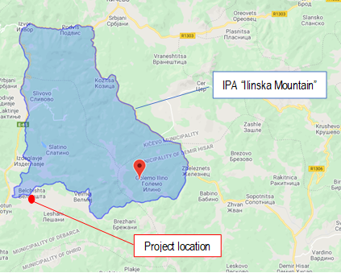 | 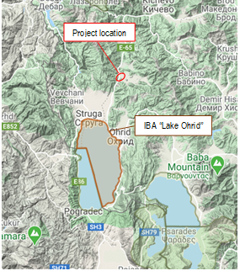
Figure 7 Location of IPA “Ilinska Mountain” related to project location | Figure 8 Location of IВA “Lake Ohrid” related to project location
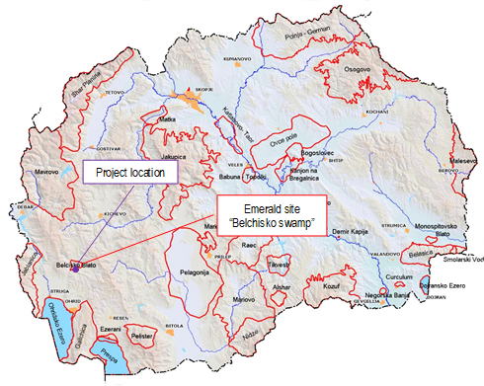 | 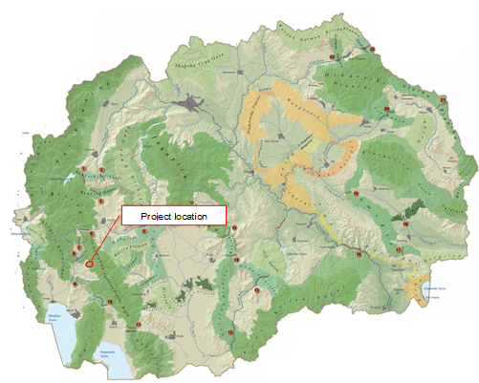
Figure 9 Location of Emerald site “Belchisko swamp” related to project location |  | Figure 10 Location of the project location related to MAK-NEN network (bio corridor for brown bear)

Annex 2 Layouts of the local road in Municipality of Debrca
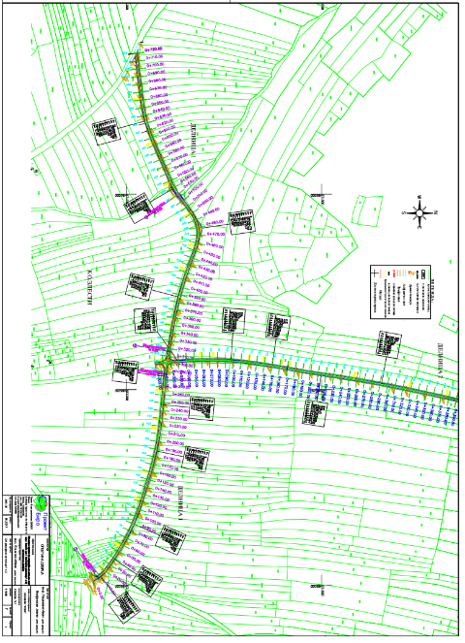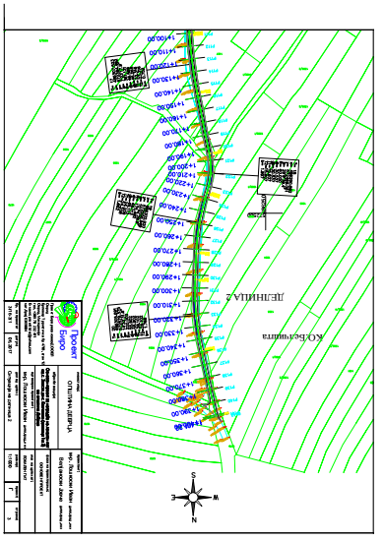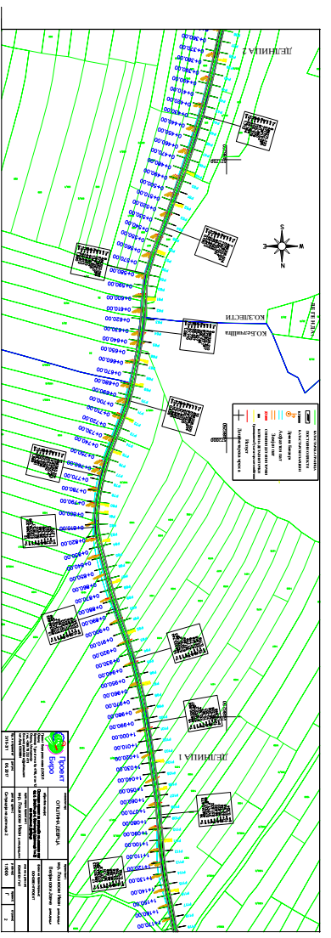
Figure 11 Graphic figures of the layout of relevant local road
Annex 3 COVID-19 considerations in construction/civil works projects
Taking into account the new situation with the appearance of the virus COVID 19, besides the standard measures for safety and protection at work it is necessary to implement measures for protection from COVID 19.
Undoubtedly, the Contractors will face many challenges in the new situation, such as:
- Inability to purchase protective equipment and disinfectants due to lack on the market,
- Lack of labour due to limited movement and absences from work,
- Inability to provide materials and work equipment due to congestion in all segments of life in the country,
- Employees' concerns about their livelihoods due to reduced workload, etc.
First, it is necessary to implement the measures for protection from COVID 19 adopted by the Government of the Republic of Northern Macedonia at the proposal of the Commission for Infectious Diseases and the Ministry of Health. These measures should be constantly updated in accordance with the latest provisions introduced by the Government. The Contractor is required to nominate a responsible person who will follow the measures adopted by the Government and will apply them in the operation of the construction site at the project location.
Links of the national institutions responsible for COVID 19 where the Contractor could find updated information and recommendations:
- Government of the Republic of North Macedonia - https://vlada.mk/node/20488?ln=en-gb
- Ministry of Health - http://zdravstvo.gov.mk/korona-virus/
- Ministry of Labour and Social Policy - http://mtsp.gov.mk/covid-19.nspx
- Ministry of transport and communications - http://mtc.gov.mk/Preporaki%20od%20Vlada
- Official site for COVID – 19 - https://koronavirus.gov.mk/en
On national level in addition to the measures introduced by the Government for protection from COVID 19, the Macedonian Occupational Safety and Health Association developed a Guide to Safety and Health at Work in Construction Prevention from the Corona virus. The Guide contains measures that the Contractor is required to implement in order to eliminate the possible ways of obtaining and transmitting COVID 19 among the workers on construction site.
In more detail in several chapters, the Guide contains:
- Challenges in construction;
- Obligations for the Contractor;
- Obligations for workers;
- Liabilities for Investors;
- Ways of proceeding in cases of suspected case or cases infected with COVID 19;
- Contact phones of national institutions responsible for contacting the occurrence of the event infected with COVID 19.
The text of the Guide to Safety and Health at Work in Construction Prevention from the Corona virus on the Macedonian language is given on the following link http://mzzpr.org.mk/wp-content/uploads/2020/04/covid19-%D0%B3%D1%80%D0%B0%D0%B4%D0%B5%D0%B6%D0%BD%D0%B8%D1%88%D1%82%D0%B2%D0%BE.pdf.
The Contractor also needs to implement the requirements introduced by the World Bank related to the protection of COVID 19.
Regarding the COVID-19 considerations in construction/civil works projects given by the World Bank, they are divided in several segments/issues and in details are shown on Table 3.

Table 4 COVID-19 considerations in construction/civil works projects recommended by WB
COVID-19 considerations in construction/civil works projects
Covid-19 issues | Type of activities
The Contractor should identify measures to address the COVID-19 situation taking into account the location, existing project resources, availability of supplies, capacity of local emergency/health services, the extent to which the virus already exist in the area.
PIU and Contractor should establish specific procedures for addressing COVID 19 issues on the construction site. Procedures should be implemented, documented and updated in accordance with the latest changes introduced by the Government and the conditions on the construction site.
Assessing workforce characteristics | • The Contractor should prepare a detailed profile of the project work force, key work activities, schedule for carrying out such activities, different durations of contract and rotations;  • This should include a breakdown of workers who reside at home (i.e. workers from the community), workers who lodge within the local community and workers in on-site accommodation (i.e. workers camp). Where possible, it should also identify workers that may be more at risk from COVID-19, those with underlying health issues or who may be otherwise at risk;  • Consideration should be given to ways in which to minimize movement in and out of site. This could include lengthening the term of existing contracts, to avoid workers returning home to affected areas, or returning to site from affected areas.
Entry/exit to the work site and checks on commencement of work | • Establishing a system for controlling entry/exit to the site, securing the boundaries of the site, and establishing designating entry/exit points (if they do not already exist). Entry/exit to the site should be documented;  • Training security staff on the (enhanced) system that has been put in place for securing the site and controlling entry and exit, the behaviors required of them in enforcing such system and any COVID -19 specific considerations;  • Training staff who will be monitoring entry to the site, providing them with the resources they need to document entry of workers, conducting temperature checks and recording details of any worker that is denied entry;  • Confirming that workers are fit for work before they enter the site or start work. While procedures should already be in place for this, special attention should be paid to workers with underlying health issues or who may be otherwise at risk. Consideration should be given to demobilization of staff with underlying health issues;  • Checking and recording temperatures of workers and other people entering the site or requiring self-reporting prior to or on entering the site;  • Providing daily briefings to workers prior to commencing work, focusing on COVID-19 specific considerations including cough etiquette, hand hygiene and distancing measures, using demonstrations and participatory methods;  • During the daily briefings, reminding workers to self-monitor for possible symptoms (fever, cough, and other respiratory symptoms) and to report to their supervisor or the COVID-19 focal point if they have symptoms or are feeling unwell;  • Preventing a worker from an affected area or who has been in contact with an infected person from returning to the site for 14 days or (if that is not possible) isolating such worker for 14 days;  • Preventing a sick worker from entering the site, referring them to local health facilities if necessary or requiring them to isolate at home for 14 days.
General hygiene | • Placing posters and signs around the site, with images and text in local languages (MK/ALB);  • Ensuring handwashing facilities supplied with soap, disposable paper towels and closed waste bins exist at key places throughout site, including at entrances/exits to work areas; where there is a toilet, canteen or food distribution, or provision of drinking water; in worker accommodation; at waste stations; at stores; and in common spaces. Where handwashing facilities do not exist or are not adequate, arrangements should be made to set them up. Alcohol based sanitizer (if available, 60-95% alcohol) can also be used;  - Training workers and staff on site on the signs and symptoms of COVID-19, how it is spread, how to protect themselves (including regular handwashing and social distancing) and what to do if they or other people have symptoms;  • Setting aside part of worker accommodation for precautionary self-quarantine as well as more formal isolation of staff who may be infected.
Cleaning and waste disposal | • Providing cleaning staff with adequate cleaning equipment, materials and disinfectant;  • Training cleaning staff on appropriate cleaning procedures and appropriate frequency in high use or high-risk areas;  • Where it is anticipated that cleaners will be required to clean areas that have been or are suspected to have been contaminated with COVID-19, providing them with appropriate PPE: gowns or aprons, gloves, eye protection (masks, goggles or face screens) and boots or closed work shoes. If appropriate PPE is not available, cleaners should be provided with best available alternatives;  • Training cleaners in proper hygiene (including handwashing) prior to, during and after conducting cleaning activities; how to safely use PPE (where required); in waste control (including for used PPE and cleaning materials);  • Any medical waste produced during the care of ill workers should be collected safely in designated containers or bags and treated and disposed of following relevant requirements (e.g., national - http://www.moepp.gov.mk/?nastani=%d0%bf%d1%80%d0%b5%d0%bf%d0%be%d1%80%d0%b0%d0%ba%d0%b8-%d0%b7%d0%b0-%d1%83%d0%bf%d1%80%d0%b0%d0%b2%d1%83%d0%b2%d0%b0%d1%9a%d0%b5-%d1%81%d0%be-%d0%be%d1%82%d0%bf%d0%b0%d0%b4-%d0%b7%d0%b0-%d0%b3%d1%80,  WHO). If open burning and incineration of medical wastes is necessary, this should be for as limited a duration as possible. Waste should be reduced and segregated, so that only the smallest amount of waste is incinerated.
Adjusting work practices | • Decreasing the size of work teams;  • Limiting the number of workers on site at any one time;  • Changing to a 24-hour work rotation;  • Adapting or redesigning work processes for specific work activities and tasks to enable social distancing, and training workers on these processes;  • Continuing with the usual safety trainings, adding COVID-19 specific considerations. Training should include proper use of normal PPE. While as of the date of this note, general advice is that construction workers do not require COVID-19 specific PPE, this should be kept under review;  • Arranging (where possible) for work breaks to be taken in outdoor areas within the site;  • Consider changing canteen layouts and phasing meal times to allow for social distancing and phasing access to and/or temporarily restricting access to leisure facilities that may exist on site, including gyms;  • At some point, it may be necessary to review the overall project schedule, to assess the extent to which it needs to be adjusted (or work stopped completely) to reflect prudent work practices, potential exposure of both workers and the community and availability of supplies, taking into account Government advice and instructions.
Project medical services | • Expanding medical infrastructure and preparing areas where patients can be isolated. Isolation facilities should be located away from worker accommodation and ongoing work activities. Where possible, workers should be provided with a single well-ventilated room (open windows and door). Where this is not possible, isolation facilities should allow at least 1 meter between workers in the same room, separating workers with curtains, if possible. Sick workers should limit their movements, avoiding common areas and facilities and not be allowed visitors until they have been clear of symptoms for 14 days. If they need to use common areas and facilities (e.g. kitchens or canteens), they should only do so when unaffected workers are not present and the area/facilities should be cleaned prior to and after such use.  • Training medical staff, which should include current WHO advice on COVID-19 and recommendations on the specifics of COVID-19. Where COVID-19 infection is suspected, medical providers on site should follow WHO interim guidance on infection prevention and control during health care when novel coronavirus (nCoV) infection is suspected;  • Assessing the current stock of equipment, supplies and medicines on site, and obtaining additional stock, where required and possible. This could include medical PPE, such as gowns, aprons, medical masks, gloves, eye protection, etc..;  • Review existing methods for dealing with medical waste, including systems for storage and disposal.
Local medical and other services | • Conducting preliminary discussions with specific medical facilities, to agree what should be done in the event of ill workers needing to be referred;  - Obtaining information as to the resources and capacity of local medical services (e.g. number of beds, availability of trained staff and essential supplies);  • Clarifying the way in which an ill worker will be transported to the medical facility, and checking availability of such transportation;  • Agreeing with the local medical services/specific medical facilities the scope of services to be provided, the procedure for in-take of patients and (where relevant) any costs or payments that may be involved;  • A procedure should also be prepared so that project management knows what to do in the unfortunate event that a worker ill with COVID-19 dies. While normal project procedures will continue to apply, COVID-19 may raise other issues because of the infectious nature of the disease. The project should liaise with the relevant local authorities to coordinate what should be done, including any reporting or other requirements under national law;
Instances or spread of the virus | • If a worker has symptoms of COVID-19 (e.g. fever, dry cough, fatigue) the worker should be removed immediately from work activities and isolated on site;  • The worker should be transported to the local health facilities to be tested (if testing is available and permitted under national legislation);  • If the test is positive for COVID-19 or no testing is available, the worker should continue to be isolated. This will either be at the work site or at home. If at home, the worker should be transported to their home in transportation provided by the project;  • Extensive cleaning procedures with high-alcohol content disinfectant should be undertaken in the area where the worker was present, prior to any further work being undertaken in that area. Tools used by the worker should be cleaned using disinfectant and PPE disposed of;  • Co-workers (i.e. workers with whom the sick worker was in close contact) should be required to stop work, and be required to quarantine themselves for 14 days, even if they have no symptoms;  • Family and other close contacts of the worker should be required to quarantine themselves for 14 days, even if they have no symptoms;  • If a case of COVID-19 is confirmed in a worker on the site, visitors should be restricted from entering the site and worker groups should be isolated from each other as much as possible;  • If workers live at home and has a family member who has a confirmed or suspected case of COVID-19, the worker should quarantine themselves and not be allowed on the project site for 14 days, even if they have no symptoms;  • Workers should continue to be paid throughout periods of illness, isolation or quarantine, or if they are required to stop work, in accordance with national law;  • Medical care (whether on site or in a local hospital or clinic) required by a worker should be paid for by the employer.
Continuity of supplies and project activities | • Identify back-up individuals, in case key people within the project management team (PIU, Supervising Engineer, Contractor, sub-contractors) become ill, and communicate who these are so that people are aware of the arrangements that have been put in place;  • Document procedures, so that people know what they are, and are not reliant on one person’s knowledge;  • Understand the supply chain for necessary supplies of energy, water, food, medical supplies and cleaning equipment, consider how it could be impacted, and what alternatives are available. Early pro-active review of international, regional and national supply chains, especially for those supplies that are critical for the project, is important (e.g. fuel, food, medical, cleaning and other essential supplies). Planning for a 1-2 month interruption of critical goods may be appropriate for projects in more remote areas;  • Place orders for/procure critical supplies. If not available, consider alternatives (where feasible);  • Consider existing security arrangements, and whether these will be adequate in the event of interruption to normal project operations;  • Consider at what point it may become necessary for the project to significantly reduce activities or to stop work completely, and what should be done to prepare for this, and to re-start work when it becomes possible or feasible.
Contingency planning for an outbreak | The contingency plan to be developed at each site should set out what procedures will be put in place in the event of COVID-19 reaching the site. The contingency plan should be developed in consultation with national and local healthcare facilities and follow state guidance for COVID-19 response, to ensure that arrangements are in place for the effective containment, care and treatment of workers who have contracted COVID-19. The contingency plan should also consider the response if a significant number of the workforce become ill, when it is likely that access to and from a site will be restricted to avoid spread.  Contingencies should be developed and communicated to the workforce for:  • Isolation and testing procedures for workers (and those they have been in contact with) that display symptoms;  • Care and treatment of workers, including where and how this will be provided;  • Getting adequate supplies of water, food, medical supplies and cleaning equipment in the event of an outbreak on site, especially should access to the site become restricted or movements of supplies limited.  Specifically, the plan should set out what will be done if someone may become ill with COVID-19 at a worksite. The plan should:  • Set out arrangements for putting the person in a room or area where they are isolated from others in the workplace, limiting the number of people who have contact with the person and contacting the local health authorities;  • Consider how to identify persons who may be at risk (e.g. due to a pre-existing condition such as diabetes, heart and lung disease, or as a result of older age), and support them, without inviting stigma and discrimination into your workplace; and  • Consider contingency and business continuity arrangements if there is an outbreak in a neighboring community.  Contingency plans should consider arrangements for the storage and disposal arrangements for medical waste, which may increase in volume and which can remain infectious for several days (depending upon the material). The support that site medical staff may need, as well as arrangements for transporting (without risk of cross infection) sick workers to intensive care facilities or into the care of national healthcare facilities should be discussed and agreed.  Contingency plans should also consider how to maintain worker and community safety on site should sites closed to comply with national or corporate policies, should work be suspended or should illness affect significant numbers of the workforce. It is important that worksite safety measures are reviewed by a safety specialist and implemented prior to work areas being stopped.
Training and communication with workers | • Regular information and engagement with workers (e.g. through training, town halls, tool boxes) that emphasizes what management is doing to deal with the risks of COVID-19. Workers should be given an opportunity to ask questions, express their concerns, and make suggestions;  • Training should address issues of discrimination or prejudice if a worker becomes ill and provide an understanding of the trajectory of the virus, where workers return to work;  • Training should cover all issues that would normally be required on the work site, including use of safety procedures, use of construction PPE, occupational health and safety issues, and code of conduct, taking into account that work practices may have been adjusted;  • Communications should be clear, based on fact and designed to be easily understood by workers, for example by displaying posters on handwashing and social distancing, and what to do if a worker displays symptoms.
Communication and contact with the community | • Communications should be clear, regular, based on fact and designed to be easily understood by community members;  • Communications should utilize available means. In most cases, face-to-face meetings with the community or community representatives will not be possible. Other forms of communication should be used; online platforms, social media, posters, pamphlets, radio, text messages, virtual meetings. The means used should take into account the ability of different members of the community to access them, to make sure that communication reaches these groups;  • The community should be made aware of procedures put in place at site to address issues related to COVID-19. This should include all measures being implemented to limit or prohibit contact between workers and the community. The community should be made aware of the procedure for entry/exit to the site, the training being given to workers and the procedure that will be followed by the project if a worker becomes sick.
Covid-19 reporting | Contractor should report an outbreak for a ‘Serious’ incident. The Contractor should keep the Borrower informed of any concerns or problems associated with providing care to infected workers on project sites, particularly if infection rate is approaching 50% of the workforce.

Annex 4 Form for submitting comments
Form for submitting comments and suggestions for Environmental and Social Management Plan (ESMP) for the project “Upgrading of local road from village Zlesti to village Belchista (section 1 and 2)”, in Municipality of Debrca
Main description of the project
The aim of the relevant project is to improve the road infrastructure in Municipality of Debrca trough upgrading the local road from the village Zlesti to the village Belchishta, which is consist of two sections: Section 1 (with length of 720 m) and Section 2, (with length of 1,401 m). The total length of the road is 2,121 m. According the Main design for the project, the main activities will include: removal of low steamed vegetation (bushes), earthworks (excavations), excavation and installation of pipe culverts, setting a buffer layer and asphalting), etc. Currently, the route is asphalted with an average width of 3.0 m, but due to the long life and its poor maintenance, in some places there have been holes and subsidence. The upper side of the road construction is worn out. Completely upgrading process of the local road is planned to be finished within 30 days. Since this is an existing road, no significant environmental impacts are expected, but for the identified impacts, the ESMP is prepared where appropriate measures for their mitigation and minimization are prescribed.
Electronic version of Environmental and Social Management Plan (ESMP) for the project “Upgrading of local road from village Zlesti to village Belchista (section 1 and 2)”, in Municipality of Debrca is available on the following web pages:
- Municipality of Debrca: https://debrca.gov.mk/
- MoTC PIU: http://mtc.gov.mk/
Name and surname of the person who provides comment*

Contact information* | E-mail:  ______________________________  Phone:  ______________________________
Comment on the ESMP:

Signature  ______________________ |  | Date  ____________________
If you have any comments/suggestions or amendments to the proposed measures of Environmental and Social Management Plan ESMP for the project “Upgrading of local road from village Zlesti to village Belchista (section 1 and 2)”, in Municipality of Debrca, please submit it to the responsible persons from the following institution:
Contact person: Irena Paunovikj
e-mail: irena.paunovikj.piu@mtc.gov.mk

Within the 14 days period after the announcement of ESMP for the project “Upgrading of local road from village Zlesti to village Belchista (section 1 and 2)”, in Municipality of Debrca
(date of announcement: ……. )
Referent number: ______________________________
(fulfilled by the responsible persons for the project implementation)

* Fulfillment of the fields with personal data is not obligatory
Annex 5 Grievance Form for whole project implementation period
Reference Number
Full name (optional)
- I wish to raise my grievance anonymously.
- I request not to disclose my identity without my consent.
Contact information  Please mark how you wish to be contacted (by post, telephone, e-mail). | - By Post: Please provide mailing address:  ________________________________________________________________________________________________________________________________________________________________________  - By telephone: ___________________________________________________  - By E-mail
Preferred language of communication | - Macedonian  - Albanian  - Turkish  - Other: ____________________
Gender | - Female  - Male
Description of Incident for Grievance |  | What happened? Where did it happen? Whom did it happen to? What is the result of the problem?
Date of Incident / Grievance
- One-time incident/grievance (date ________________)
- Happened more than once (how many times? ______)
- On-going (currently experiencing problem)
What would you like to see happen?
Signature: _______________________________
Date: _______________________________

Please return this form to:

Name and surname | Irena Paunovikj | Ljupco Baleski | -------------------------------
E-mail | irena.paunovikj.piu@mtc.gov.mk | ljupco.baleski@gmail.com | ------------------------------------
Institution | Ministry of Transport and communications | Municipality of Debrca | Contractor Company
Local Roads Connectivity Project
St. Dame Gruev 6,1000 Skopje, R. N. Macedonia

